XCRAM
Use Case Diagram

Submitted to:

Prof. Ma. Rowena C. Solamo
Faculty Member
Department of Computer Science
College of Engineering
University of the Philippines, Diliman

Submitted by:
Agluba, Gerry Jr. P.
Go, Sharleen Joy Y.
Silverio, Robelle C.

In partial fulfillment of Academic Requirements
for the course
CS 191 Software Engineering I
of the
1st Semester, AY 2016-2017
Unique Reference:
The documents are stored in the [GitHub Repository Link].
[File Reference in GitHub, preferably link.]

Document Purpose:
The purpose of this document is to give a simple, visual representation of the functionalities of our scheduling software(XCRAM) through a use-case model. This includes the use-case diagram, actor and use-case description.

Target Audience:
Evaluators and Users.

Revision Control

History Revision:
Revision Date | Person Responsible | Version  Number | Modification
9/22/16 | Gerry Agluba | 1.0 | Initial Document. Added the Document Purpose, Target Audience, Use-Case Diagram and System Description.
9/23/16 | Sharleen Joy Go | 2.0 | Edited the Document Purpose and System Description. Added the Delete Saved Schedule and View Saved Schedules use-cases in the diagram. Wrote the description for each use-case.
9/28/16 | Robelle Silverio | 3.0 | Changed the Use-Case Diagram.
9/28/16 | Sharleen Joy Go | 4.0 | Added descriptions for Use-Cases Input Task Information, View Task Schedule and Delete Task Schedule. Edited the descriptions of use-cases Add Task and Edit Task. Changed the numbering of the use-cases.

System Name: Task Scheduling System

Description: The system is basically an interconnection between the user and all the functionalies
provided by the task scheduler. The user feeds this system with a series of tasks information. In return, this system's functionalitites work together to provide the user with a schedule of tasks that satisfies all conditions inputted by the user for each task.

Use-Case Diagram:

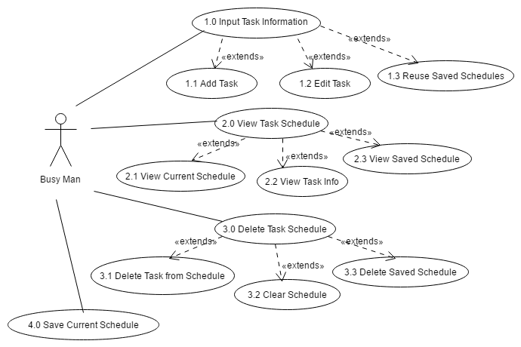

List of Actors:
Actors | Description
Busy Man | This is any person who has a hand full of tasks but possibly doesn't have a sense of organization. He has access to all of the use-cases of the system. From this actor, the system receives commands such as: add a new task in the schedule, delete a task from the current schedule, edit a task's information from the current schedule, clear the current schedule, view a certain task's information, display the current schedule, save the current schedule, view a saved schedule, reuse a saved schedule and delete a schedule from the list of saved schedules. The system's major input, the tasks, will solely come from this actor. At the same time, this actor will receive the system's major output: the schedule.

List of Use-cases:
Use-Case | Description
Use-Case 1.0 Input Task Information | The purpose of this use-case is solely to obtain any sort of information from the user regarding the desired schedule.
Use-Case 1.1 Add Task | The purpose of this use-case is to allow the Busy Man to add a new task to the current schedule. The Busy Man will input the task title, type (fixed or flexible: fixed tasks must be done on a specific time while flexible tasks may be done at any time during the day but may be controlled to some extent by adding constraints), and duration. If the inputted task was fixed, the Busy Man will be asked to enter the start time of the task. If the inputted task was flexible, the Busy Man will be given options to add a priority and constraints such as a preferred time range for the task to be done and the possibility of partitioning the said task.
Use-Case 1.2 Edit Task | This use-case allows the Busy Man to edit the information of any task in the current schedule. For fixed tasks, its start time, title and/or duration may be changed. For flexible tasks, its title, priority and/or duration may be changed. Also, its constraints may be changed or deleted.
Use-Case 1.3 Reuse Saved Schedule | This use-case will allow the Busy Man to reuse any of his saved schedules. The saved schedules' names would be listed and the Busy Man would choose from one of them. Afterwards, the chosen schedule will be loaded as the current schedule. Without this use-case, the schedules stored by the Save Schedule use-case would be futile.
Use-Case 2.0 View Task Schedule | The purpose of this use-case is to allow the user to view any information that the user had previously entered into the system.
Use-Case 2.1 View Current Schedule | This use-case will allow the Busy Man to view the schedule that the system has made given all the Busy Man's inputs. Each task's title will appear along side its allotted time range and they will be sorted in increasing order of time.
Use-Case 2.2 View Task Info | The Busy Man may view a specific task's information through this use case. The task title, type, start time, end time, duration, priority and constraints will be displayed.
Use-Case 2.3 View Saved Schedules | This use-case will allow the Busy Man to view any of his saved schedules. The saved schedules' names would be listed and the Busy Man may choose to view any of them. The chosen schedule will be displayed in the same manner as the View Current Schedule use-case displays the current schedule.
Use-Case 3.0 Delete Task Schedule | The purpose of this use-case is to delete any information that the user had previously entered into the system.
Use-Case 3.1 Delete Task from Schedule | The Busy Man may delete any task from the current schedule through this use-case. After the selected task is deleted, the resulting schedule is exactly the same as the old one except for the absence of the deleted task.
Use-Case 3.2 Clear Schedule | If at some point the Busy Man wishes to create a completely new schedule, he may delete all the tasks from the current schedule through this use-case.
Use-Case 3.3 Delete Saved Schedule | This use-case will allow the Busy Man to removed any schedule from the list of saved schedule. The saved schedules' names will be listed. Afterwards, the chosen schedule will be permanently removed from the list and may no longer be viewed or reused.
Use-Case 4.0 Save Current Schedule | If the Busy Man wishes to save the current schedule for future use, he may do so through this use-case. The Busy Man will be asked to name the current schedule, then this use-case will add the schedule to the list of saved schedules. This use-case will come in handy when there is some set of tasks which needs to be repeated in the future given the exact same conditions for each task.

